457.557 Water Resources Systems Engineering, Spring 2022
Quiz #2, May-03, 2022 (30 mins, 40 pts total)
Student Number: ___________________ Name: ___________________

I) Multiple Choice Questions (4 pts each, 8 pts total)
- Choose the correct word for the blank in the following sentence:
Calculus-based optimization models (such as hill climbing or Lagrange multipliers) are difficult to be adopted in real-world problems since the objective functions should be ________________.
- Continuous
- Differentiable
- Both (a) and (b)
- None of the above

- Which of the following is NOT an element of Genetic Algorithm (GA)?
- Genes
- Fitness
- Chromosomes
- Population

II) Short/Long Answers (8 pts each, 32 pts total)
- Write the recursive equation of a deterministic DP model that minimizes the objective function ${TSD}_{t}(S_{t},R_{t},S_{t+1})$. Assume that you are solving in backward direction. The values of the remaining minimum sums of weighted squared deviations is $F_{t}^{n}\left(S_{t},Q_{t}\right)=min\sum_{t=1,n}{{TSD}_{t}(S_{t},R_{t},S_{t+1})}$.

- What are the three curses of stochastic dynamic programming (SDP) models?
(a) Name the three curses, and (b) briefly explain about the three curses. You may refer to the following equation (recursive equation) of SDP for your explanations.

(1)

(2)

(3)

- Dynamic programming models divides the original optimization problem into a set of smaller optimization problems, each of which need to be solved before the overall optimum solutions to the original problem can be identified. Graphically, DP can be illustrated with the following figures:
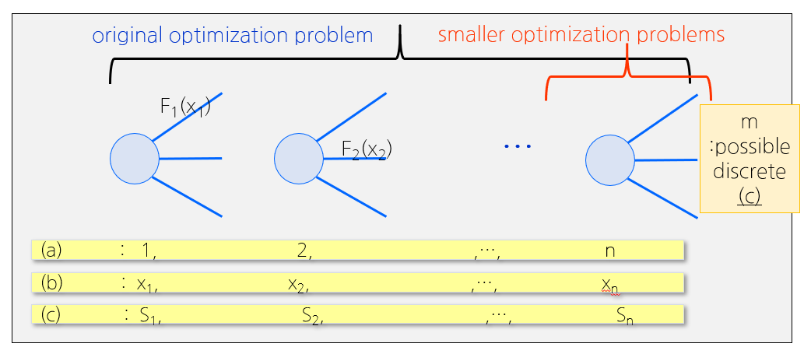
Fill in the blanks for (a), (b), and (c).
- ______________________
- ______________________
- ______________________

- What is the fundamental concept behind Pareto Optimality?
(a) First, explain the concept of Pareto optimality using either equations or figures. (b) Then, briefly explain the benefits of using optimization algorithms which target to solve multi-objective problems.

